

Design Document

TOOLS EXTERNALIZATION
Version 1.0

REVISION HISTORY

Version | Date | Description | AuTHOR
1.0 | 09-05-2016 | Initial Draft | Sandeep Kiranraj Jain

Contents

1 Requirement Overview 3
2 References 3
2.1 Other Feature / Story dependencies 3
3 Functional Requirements 4
4 Design guidelines 4
4.1 Requirement Details 4
5 Agent Changes 5
5.1 DAG Agent changes 5
5.2 Test Agent changes 5
6 Impact Analysis and Components 5
7 Architecture Overview 5
7.1 Splunk 9
7.2 YSL 10
7.3 YCC New App 10
7.4 New APIs defined 10
8 CABAL 10
8.1 DBCabal details 10
8.2 SDKCabal details 10
8.3 REST Cabal details 10
9 Detailed Design 11
9.1 CSS impact 13
9.2 ADA / WCGA impact 13
9.3 Cache requirements 13
9.4 Deprecated - Service or Components 13
10 External Libraries 13
10.1 Application libraries 14
10.2 Core External Libraries 14
11 Configurations 14
11.1 Param Keys 14
11.2 ACL 14
11.3 Config Tools 14
11.4 JVM Arguments 14
11.5 Label Changes 14
12 Build and Installer Changes 14
12.1 Jar file change 14
13 Documentation Impact 15
14 Performance Requirements 15
15 Security Requirements 15
16 Deployment Requirements 15
17 Data Migration 15
18 Operational Changes 15
18.1 Certificates 15
18.2 JVM Memory changes 15
18.3 Deployment Models 15
18.4 CDN 16
18.5 New Instance / Hardware Provisioning 16
18.6 CTier changes 16
19 Production Verification Tool (PVT) Dependencies 16
20 Testing Impact 16
21 Is this Feature Switchable 16
22 Unit & Integration Testing 16
High level test scenarios 16
23 REVIEW HISTORY 17
23.1 Design Review 17
23.2 Code Review 17
24 Glossary Of Terms 18
25 Scope of Testing 18
26 Test Environment and Stack 18
27 Test Approach 18
28 Major Use Cases 18

Requirement Overview
Tools Externalization is a new functionality which will let Yodlee Customer Care consumers and API consumers know all the information related to refresh and meta data for all sites enabled for the client.

This functionality will create transparency between Yodlee and its customers which will in-turn build a good relationship. This will also help the client to understand/solve issues/queries on their own and not dependent on Yodlee to provide information thereby reducing the turn-around time(TAT).

Customers can leverage the feature to know what they are really looking for and reduce the to and fro queries to Yodlee. Yodlee can observe reduction in incoming SRs.

References

Other Feature / Story dependencies
- YSL Framework release
We will have a separate instance of YSL Framework for Tools Externalization, so any release from platform end should be in sync for our usage and release should be always on the latest framework code base. The customized code should be developed in compatible with latest release of YSL framework

Functional Requirements
FSD Requirement ID / Reference | System Requirement
- IPs/Ports needs to enabled for connectivity from one component to other.
- Certificates needs to be installed where ever required.
- Hardware need to have the YSL core instance running for Tools Externalization
- JDK 1.8 for App and JDK 1.7 for YSL
- J-Boss 9 For App and J-Boss 7 for YSL
- Users to be created for each module to accommodate authentication
- Allow the user to Search site
- Define the type of reports to be made available
- The pages should be made read only
- Statistical data should be made available with charts and table

Design guidelines

Requirement Details

The requirement is to expose two different set of data points to Customers –
- Site Metadata
  - Useful information related to site like URLs, MFA Type etc.
  - Information related to known/in-progress issues
- Refresh Statistics
  - Almost real time statistical data related to site behavior for the customer
  - Refresh statistics of the top aggregated sites for the customer

The above information should be available to the customers via,
- Yodlee Customer Care
The customers should be able to view the data points in a tab under existing YCC. This tab represents a new stand-alone APP which will work in compatible with YCC App and for authentication follow the SSO with YCC.

- YSL API
The customers will also be able to get this information via APIs exposed through YSL framework

The data points for the App will be available via YSL APIs which will in-turn either connect to OLTP for site metadata (using YSLanguage) or Splunk for statistical data (using REST Bridge).

Splunk will commute the raw data collected from OLTPs and provide the statistical data via REST calls. Historical data should be stored in data base.

Agent Changes

DAG Agent changes
N/A

Test Agent changes
N/A

Impact Analysis and Components
Following modules / applications will be impacted
- YCC – The new App will be integrated with YCC and utilize few of the features of YCC – SSO, Tabular flow etc.
- YSL - We will be developing parallel system to expose the data points which may require some of the framework changes.
Few new components will be introduced:
- YSL
- YCC New UI Application
- Splunk
Expected result is that all above application / module should work successfully.
Build and installer changes will be done.
New environments will be provisioned for setting up these two components.

Architecture Overview
Please see following diagram for the high level architectural changes –

- Refresh Stats Flow
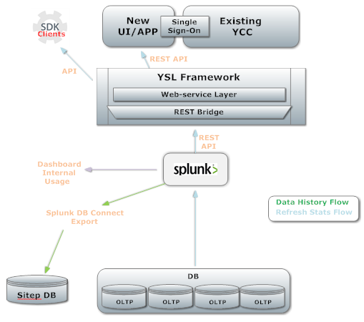

- Site Metadata flow
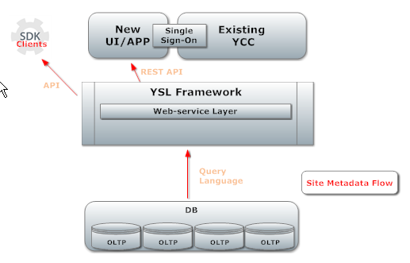

The current flow of refresh stats for utilization in any application is below for reference. And it is having a delay of 2 hours from the actual occurrence.

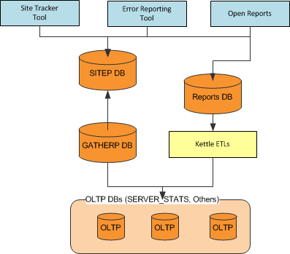

Following services will be newly added
- Splunk
- YSL
- New App

A high level flow would be like – Explanation followed by diagram
User will go to site details tab under YCC where he will have already couple of graphical/tabular reports – Overall success rate, Top 10 aggregated sites statistics. If user needs any specific site details – statistics/meta-data, we will have option to search which will flow into two different flows,
- Statistics –
  - The app will request an information to YSL API post authentication
  - YSL will internally call Splunk REST API via REST bridge. Authentication of Splunk will be part of these calls
  - Splunk will already have pre-computed reports readily available and updated from the raw data collected from SERVER_STATS table of all OLTP DB’s. This will be provided to YSL with JSON response
  - YSL will filter the data as required and send to APP instance
  - APP will commute the data received and render it as needed – Graphical/Tabular
- Site Meta Data –
  - The app will request an information to YSL API post authentication
  - YSL will internally query the OLTP data base via already pre-meditated query written in YS Language. Collected data will be mapped and JSON response will be generated
  - APP will commute the data received and render it for display

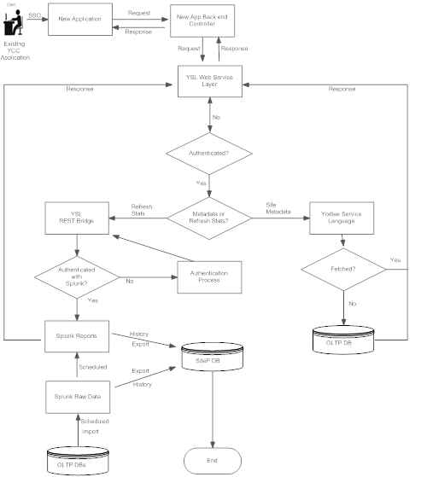

Splunk

Splunk is an Enterprise Software Platform which allows the functionality of search, analyse, visualize the data by storing it into flat files.

Some of the functionalities which comes with Splunk -
- Indexing leading to faster retrieval
- Flexible to read from various types of sources
- HTML Integration and many more

We will be utilizing this component for mainly below purposes,
- Statistical data will be computed from the raw data collected from OLTP
- REST service will provide this data to required component

YSL
YSL component will be intermittent layer which will provide the REST service to external world/client facing APP for any data to be exposed.

This collects data via two different ways
- Query language which will directly query any data base to fetch the required information
- REST Bridge which will in turn call another REST service to get the data

YCC New App

A Standalone Application which can be integrated with existing YCC Application. It will use YCC SSO facility for authentication.

The technology which we are planning to use is Angular JS, Bootstrap CSS and Spring.

New APIs defined
TBD

CABAL

DBCabal details
N/A

SDKCabal details
N/A

REST Cabal details
N/A

Detailed Design

Tools Externalization is an initiative to create transparency to the customers related to site related information. The major queries for any information today from customers are mainly related to the site. This tool will provide Self Serving BI for the customers thereby reducing lot of to and fro for the same information. The main purpose is to improve the turn-around time and reduce incoming SRs.

Below are the details of the components involved, their role and flow of the information -

Splunk – Statistical Data and History
Splunk is an enterprise software which provides platform to search, visualize and analyze any kind of data. The data retrieval is faster due to its indexing techniques and storage in the form of flat files. Splunk has its own mechanism of computing data by storing it as report – which can be scheduled/accelerated.

The main use of Splunk in this initiative is to collect the data from OLTP as soon as the data is filed in Server stats table of all OLTPs and index the data. Compute the data collected as per the use.
Below are the two main roles/functionalities of Splunk which will be used in this initiative,
- Splunk acts as a REST server and provide the latest computed data on REST calls from any client application
- Store the data into any DB using Splunk DB Connect v2 for historical needs

YSL – Intermittent Web Service Layer
With this initiative, we are planning to expose the data to all customers either via Application/APIs. For this, we are using an intermittent layer which will act as Web Service layer for the external world (API) or Client facing application. This is a standard used across the organization.

The main use of YSL in this initiative is to collect the data from various sources, filter based on needs and expose the data.
Below are the two main roles/functionalities of YSL which will be used in this initiative,
- YSL will expose the site meta data by collecting/processing the data from OLTP DB using its own query language
- YSL REST Bridge which will call the Splunk REST server to collect the data related to site statistics and expose it post filtering

YCC New Application
The initiative of going with new Application is to make it updated according to the market and come out of the current framework. This also means to make the tool loosely coupled so that any new feature can be easily developed and reduce dependency on core/other modules.

The Application will be standalone application and will be integrated with Existing YCC Application which will expose additional details on site.

Migration/Connectivity of the components

Migration of these components will involve the following steps,
- New App will be migrated with Existing YCC under some tab of the YCC application.
  - Authentication will be via SSO to existing YCC
- New App connectivity with YSL would be via REST calls.
  - Authentication will be via REST calls only
- YSL to Splunk connectivity will be via REST calls
  - Splunk follows its own authenticity and this would be via REST calls
- Splunk connectivity with the OLTP/other DB would be via DB Connect V2 component of Splunk

Flow of the request and response

Background Flow:
This doesn’t need any initiation of the request
- Splunk will compute data as reports which will be scheduled and updated from the raw data collected from SERVER_STATS table of all OLTP DB’s.
- Splunk will also push the data for storage in DB for historical needs

Normal Flow
User will go to site details tab under YCC where he will have already couple of graphical/tabular reports – Overall success rate, Top 10 aggregated sites statistics. If user needs any specific site details – statistics/meta-data, we will have option to search which will flow into two different flows,
- Statistics
Request flow
- The app will request an information to YSL API post authentication
- YSL will internally call Splunk REST API via REST bridge. Authentication of Splunk will be part of these calls
Response flow
- Splunk will already have pre-computed reports readily available and updated from the raw data collected from SERVER_STATS table of all OLTP DB’s. This will be provided to YSL with JSON response
- YSL will filter the data as required and send to APP instance
- APP will commute the data received and render it as needed – Graphical/Tabular

- Site Meta Data
Request flow
- The app will request an information to YSL API post authentication
- YSL will internally query the OLTP data base via already pre-meditated query written in YS Language.
Response flow
- Collected data will be mapped and JSON response will be generated
- APP will commute the data received and render it for display

Technology Stack
- Splunk
  - Splunk Processing Language(SPL)
  - SQL for fetching data into Splunk
- YSL
  - Yodlee Service Language
  - Spring 4.0
- New Application
  - Angular JS
  - Bootstrap CSS
  - Angular UI Component
  - Spring 4.0

CSS impact
N/A

ADA / WCGA impact
N/A

Cache requirements
TBD

Deprecated - Service or Components
N/A

External Libraries

Application libraries
- Angular JS Libraries
- Bootstrap CSS
- Splunk SDK Jar

Core External Libraries
N/A

Configurations
N/A

Param Keys
N/A

ACL
N/A

Config Tools
TBD

JVM Arguments
TBD

Label Changes
TBD

Build and Installer Changes
New build scripts need to be created for below components,
    - New App & Existing YCC
    - YSL installations

Jar file change
TBD

Documentation Impact

Document | Impacted  (Yes/No) | Comments | Reviewed
Version Upgrade | Yes
CBDK | No
ACL Guide | Yes
Javadoc | Yes
Alerts Guide | No
SDK Guide | Yes
Client facing diagram | No

Performance Requirements
TBD – as this is a new Application, we need to define performance parameters

Security Requirements
TBD

Deployment Requirements
TBD

Data Migration
N/A

Operational Changes

Certificates
TBD

JVM Memory changes
TBD

Deployment Models
TBD

CDN
N/A

New Instance / Hardware Provisioning
TBD

CTier changes
TBD

Production Verification Tool (PVT) Dependencies
N/A

Testing Impact
Following application / platform modules needs to be tested;
- YCC – Old and New Application
- YSL
- Splunk

Is this Feature Switchable
Yes

Unit & Integration Testing
TBD based on POC – Splunk

High level test scenarios

Serial# | Unit Test Case | Expected Result
1 | Data Fetch from OLTP | Data being fetched/indexed regularly from server stats table of all OLTPs and available for use
2 | Reports Generated and Scheduled | Reports generated are accurate and updates at schedule time
3 | Data export into DB | Data should be exported into DB on the scheduled time for historical purpose. Should not truncate prior data in the table
4 | Authentication of Splunk via REST calls | Splunk should authenticate the request via REST call and provide session ID for further calls
5 | Data fetch via REST calls to Splunk | Splunk should return the data for the specified report in XML/JSON format

REVIEW HISTORY

Design Review

Reviewer Name
Date | S.No. | Review comments | Developers response

Code Review

Reviewer Name |  | Rafael G
Date | S.No. | Review comments | Developers response

Glossary Of Terms
<Use this section to fill out the meaning for jargons used in this design document. Do not hire jargons from Yodlee Glossary document, that should be an a implicit assumption>

Scope of Testing
<Quality Engineer defines the scope of this feature testing>

Test Environment and Stack
<Quality Engineer defines the how and which environment this feature will be tested>

Test Approach
<Quality Engineer defines the Test Approach or Strategy of this feature>

Major Use Cases
TBD

